E-Aadhar, A common man’s identity. Safe?
Every eAadhar letter is locked with a password which is a fixed string of following schema:
first_four_letters_of_name_in_uppercase + year_of_birth
Basically there are 4 uppercase alphabets & 4 digits involved. So how many combinations can be generated from 4 uppercase alphabets and 4 digits? The answer is 2821109907456 and it would take 90 years to crack the password if we try 1000 combinations per second.
We don’t have to calculate all the combinations because the password is in this form:
([A-Z][A-Z][A-Z][A-Z])([0–9][0–9][0–9][0–9])
(4 uppercase letters) (4 digits)
(Group 1) (Group 2)
The alphabets are in a group and lie before the digits which are also grouped so there’s no possibility that they can be mixed to form a combination like S2N65GE1 . So how many combinations are possible after considering that?
The number of combinations of 4 letters which can be formed by 10 digits i.e. 0-9 :
(10)⁴ = 10000
So there will be 10000 possible combinations. Now let’s calculate the same for alphabets.
(26)⁴ = 456976
And all the combinations of 10000 digit and 456976 alphabets combinations will be:
456976 * 10000 = 4569760000
And if we try 1000 combinations in 1 second we will need this much of time
4569760000 / 1000 = 4569760 seconds
or
52 days 21 hours 22 minutes and 40 seconds
These are just not 4 alphabets and 4 digits, these are first letters of the name & year of birth of someone.
A human can live up to 100 years which means someone born in 1642 can’t be alive and hence can’t have an Aadhar card.
Time traveling is also impossible at the moment which means someone who is going to be born in 2594 can’t travel back to the time to get an Aadhar card.
So the combinations ranging from 0000–9999 aren’t valid. We just need the 1920–2020 range which covers humans of age 0 to 100.
So now the number of combinations and time required is:
456976 * 100 = 45697600 combinations45697600 / 1000 = 45697.6 seconds
or
12 hours 41 minutes 37 seconds
Just like all the combinations of digits weren’t valid years of birth, similarly AAAA or PZVS aren’t valid four first for letters of an indian name.

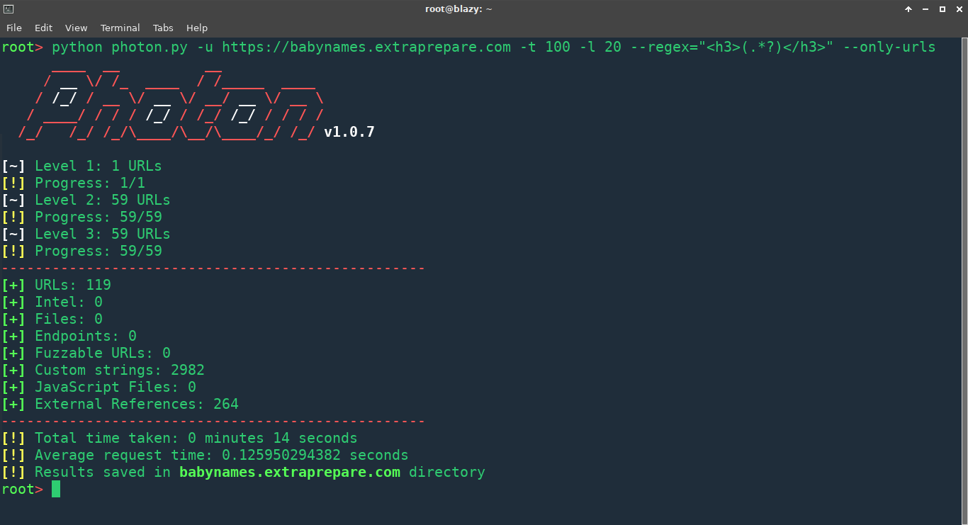
I used my Photon to scrape names from a website which was basically a directory of Indian names and I found 3283 unique names! I used the following command to extract the first 4 letters and filtering out the duplicates
grep -oP ”^\w{4}” custom.txt | sort | uniq | dd conv=ucase

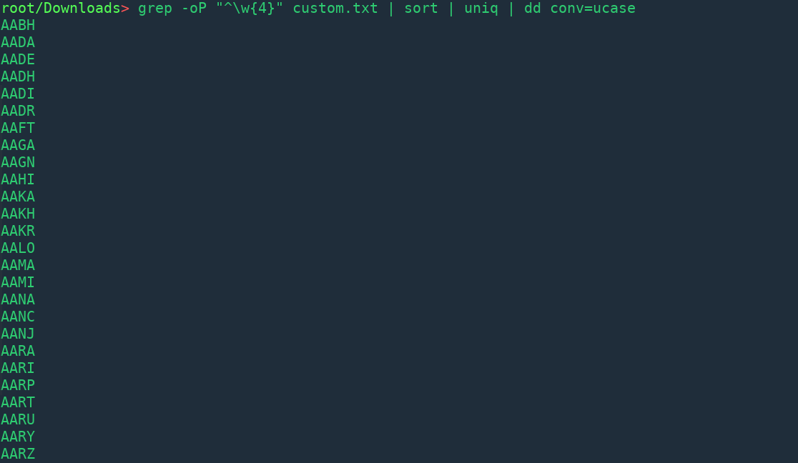
These are 1598 entries! There were many duplicates, for example the first four letters in the names Sanjeev & Sanjit are same.
Are you thinking that 1598 prefixes are too low for a population of 1.6 billion? Yep, that’s kinda of true but these are not names, these are prefixes! The wordlist can be found here, feel free to search first four letters of your name in it and most likely you will get a match.
The time required now
1598 * 100 = 159800 combinations159800 / 1000 = 159.8 seconds
or
2 minutes 39.8 seconds

